Appended new changes have been incorporated in PMS BIS

Brand & Grade:

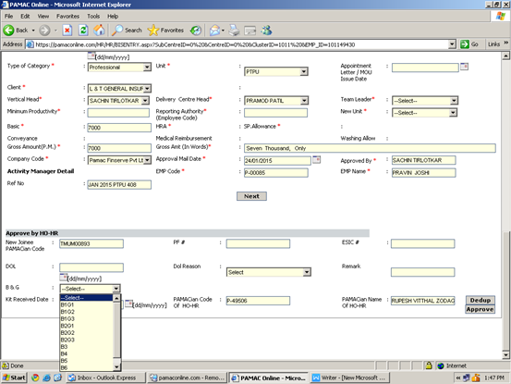

New Unit :
Already Unit option is present in BIS hence New Unit option has been added

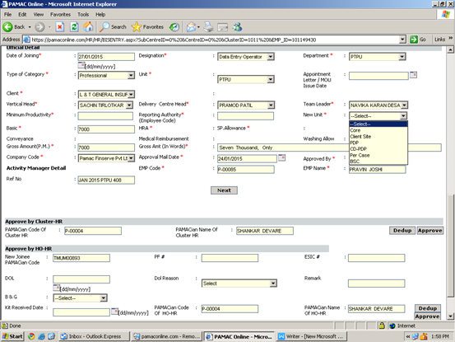

DOL & DOL Reason:

DOL & DOL reason updated in dol update page will reflect in BIS.

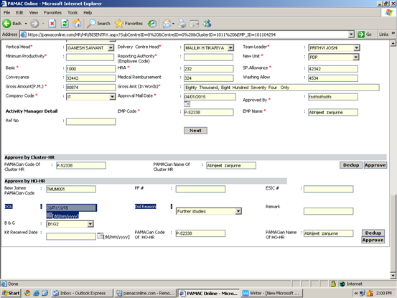

Team leader was not visible for HO HR:

Shankar sir only can view the teamleader updated in BIS centrally.
Other users need to login at respective PMS location.

